**Exp No: 1 Date: 17/07/2024**

**VIRTUALIZATION**

**CONFIGURATION AND CREATION OF VIRTUAL MACHINE**

**AIM:**

To configure a Virtual Machine using VM ware and Launch the VM and execute a simple program using C/PYTHON/JAVA.

**PROCEDURE:**

1. Launch a VM ware
2. Create new virtual machine
3. Customize the set-up
4. Set username and password
5. Browse for .iso file of an operating system
6. Configure the hardware capacity
7. Finish and power on the VM
8. Install C or PYTHON OR JAVA Compiler and execute a simple program

**OUTPUT:**

**Typical Configuration:**

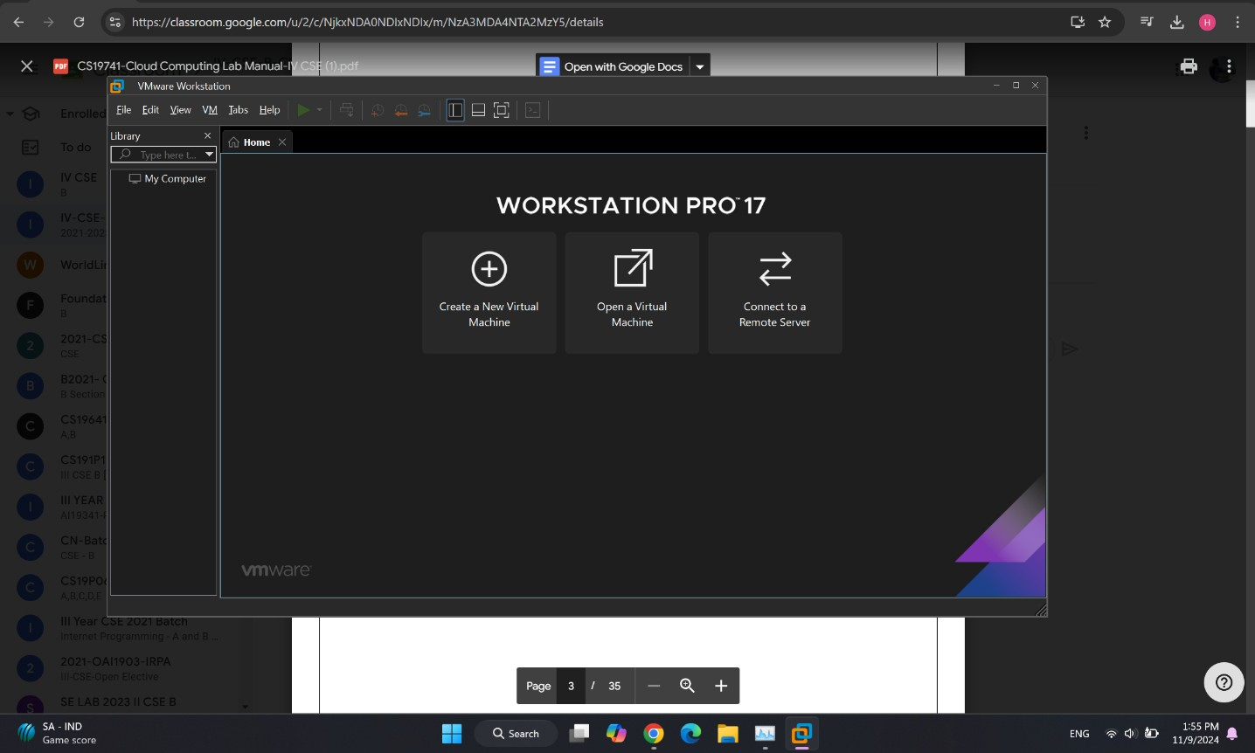

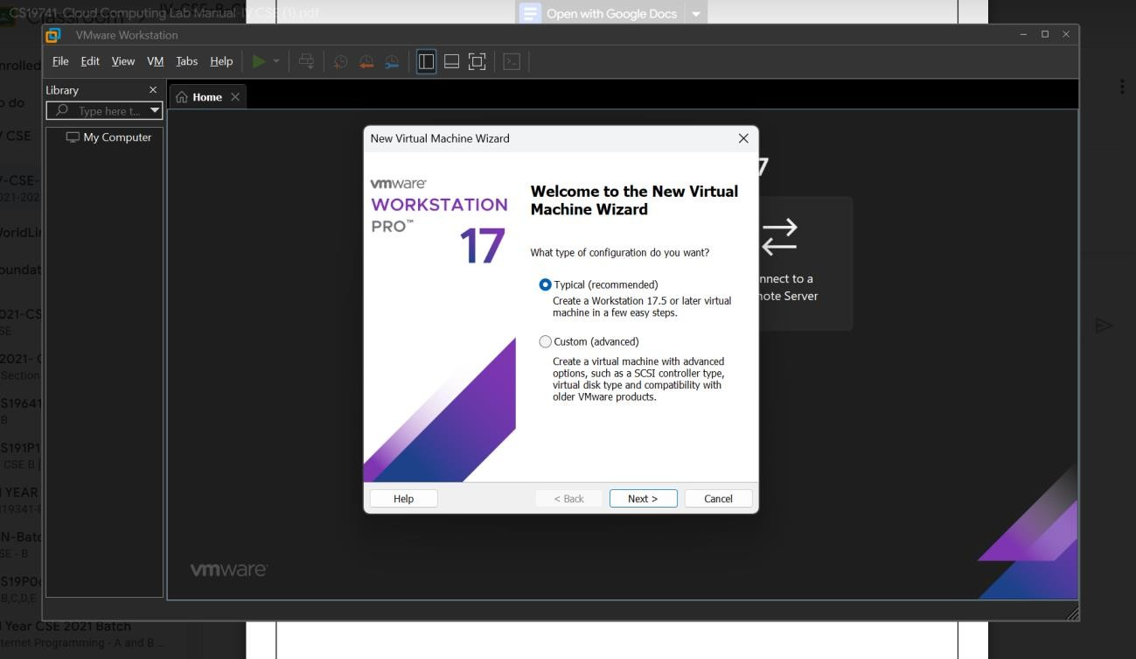

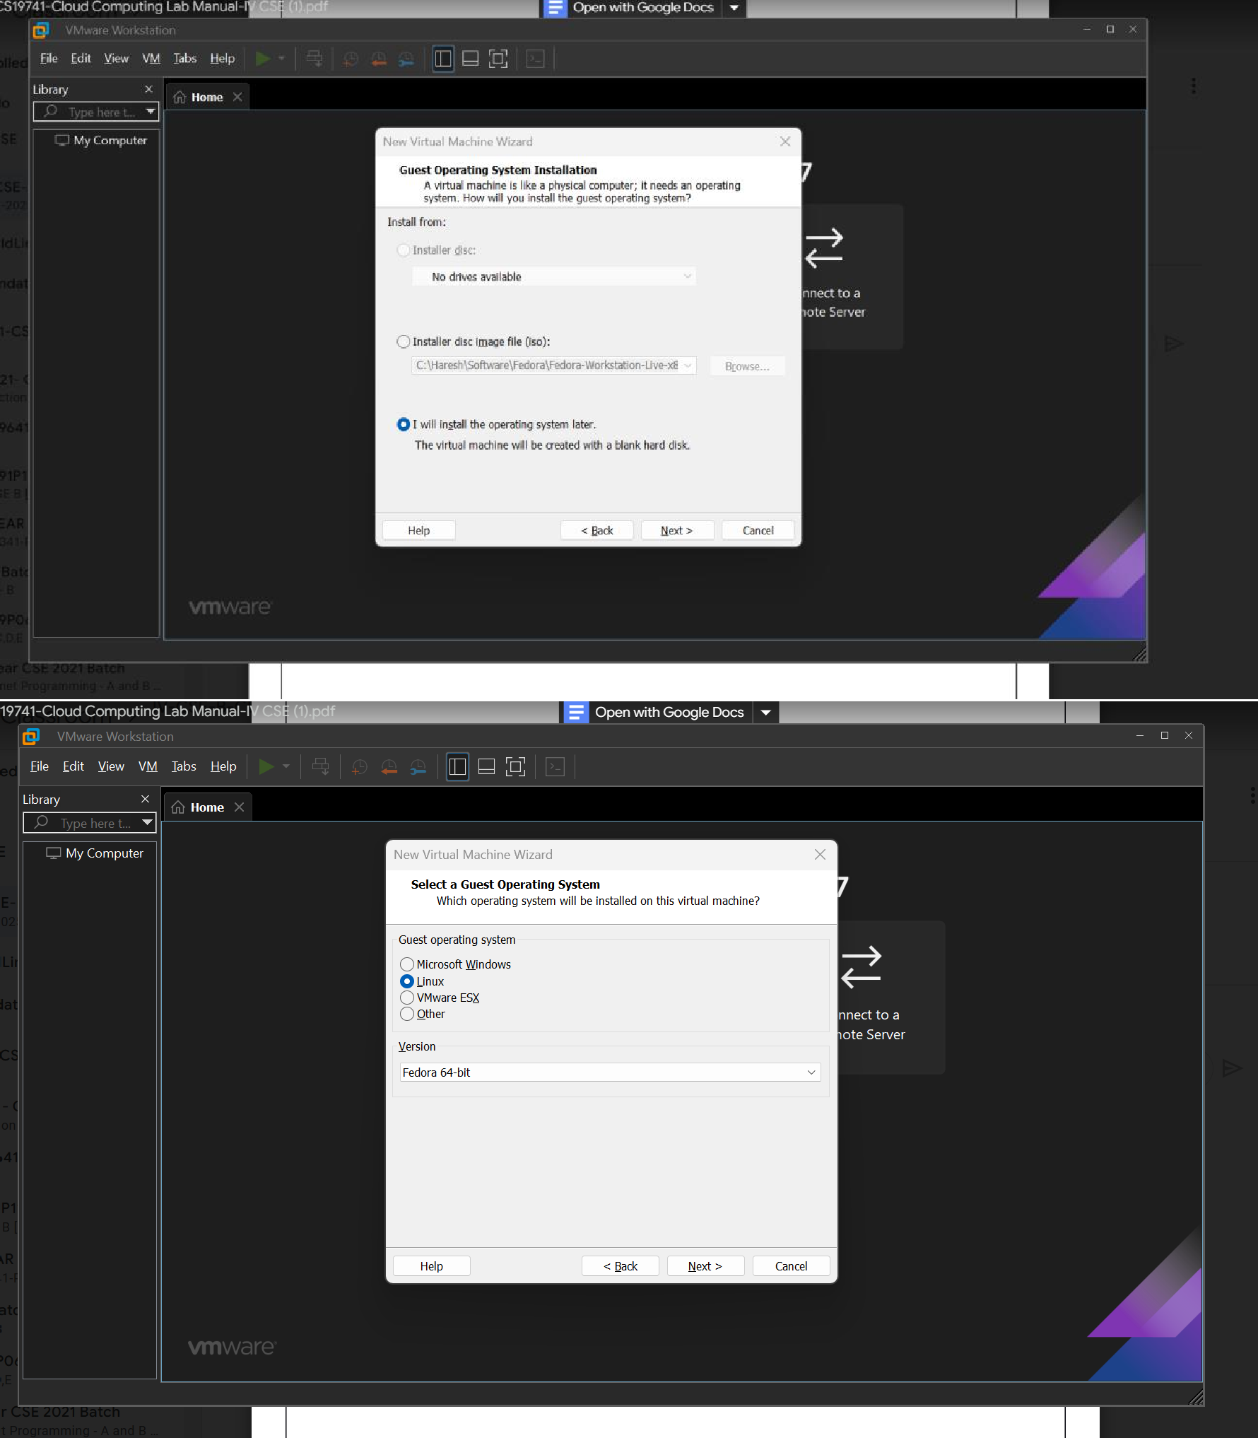

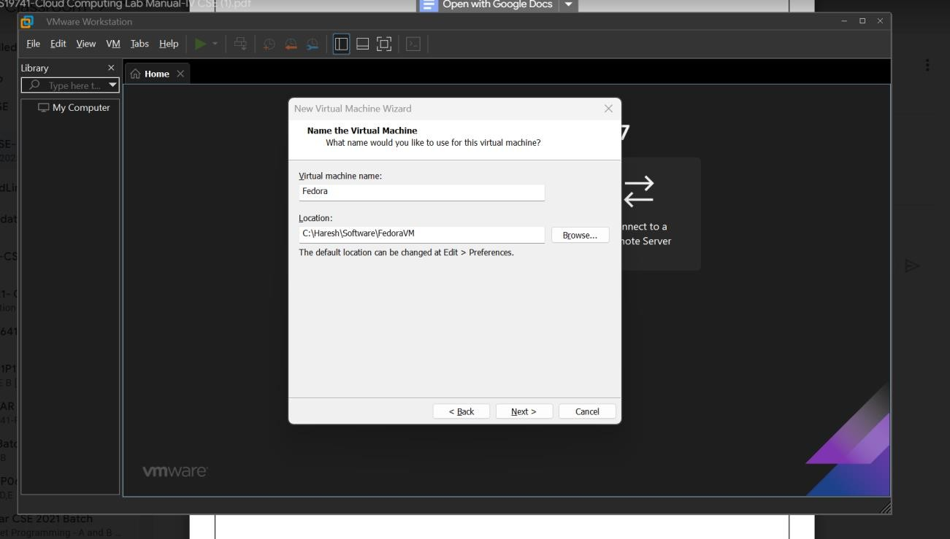

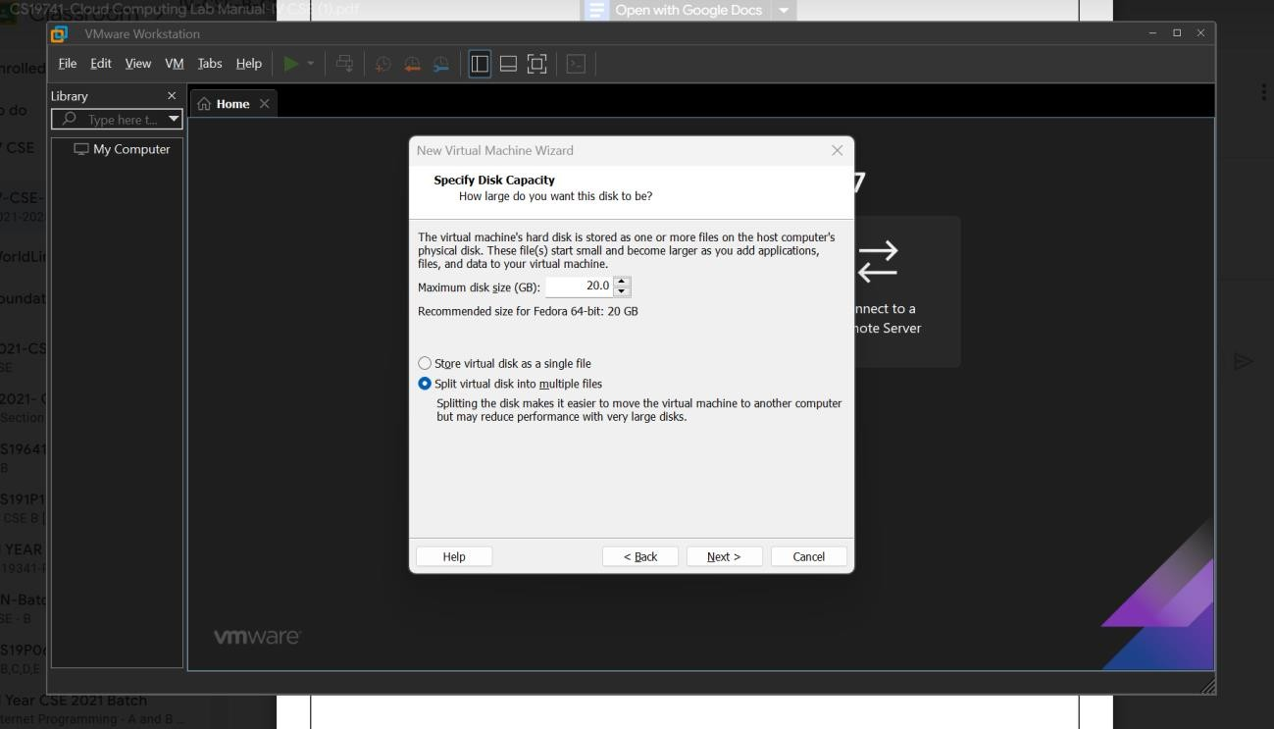

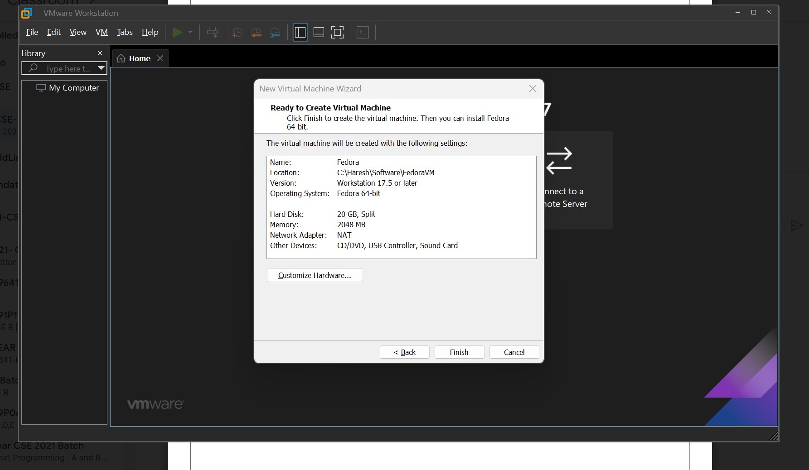

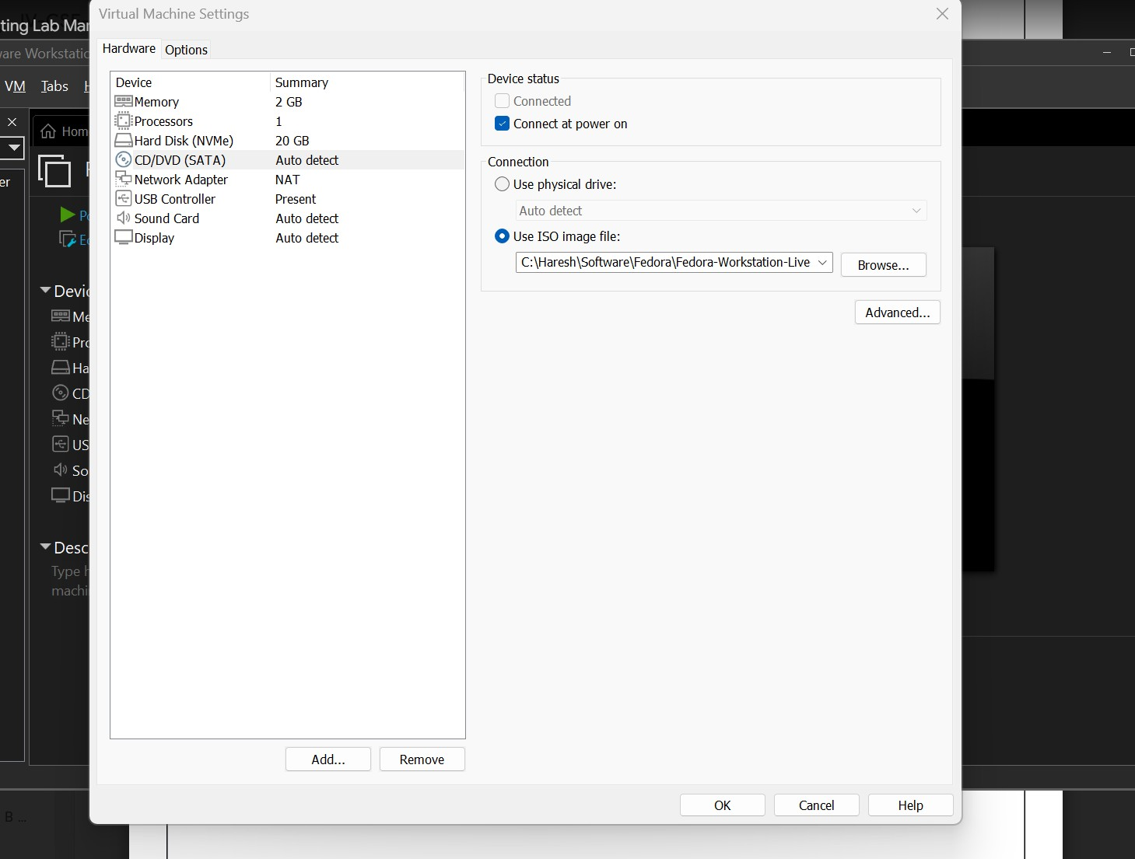

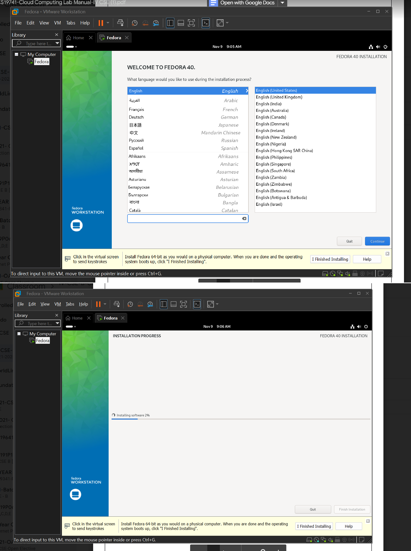

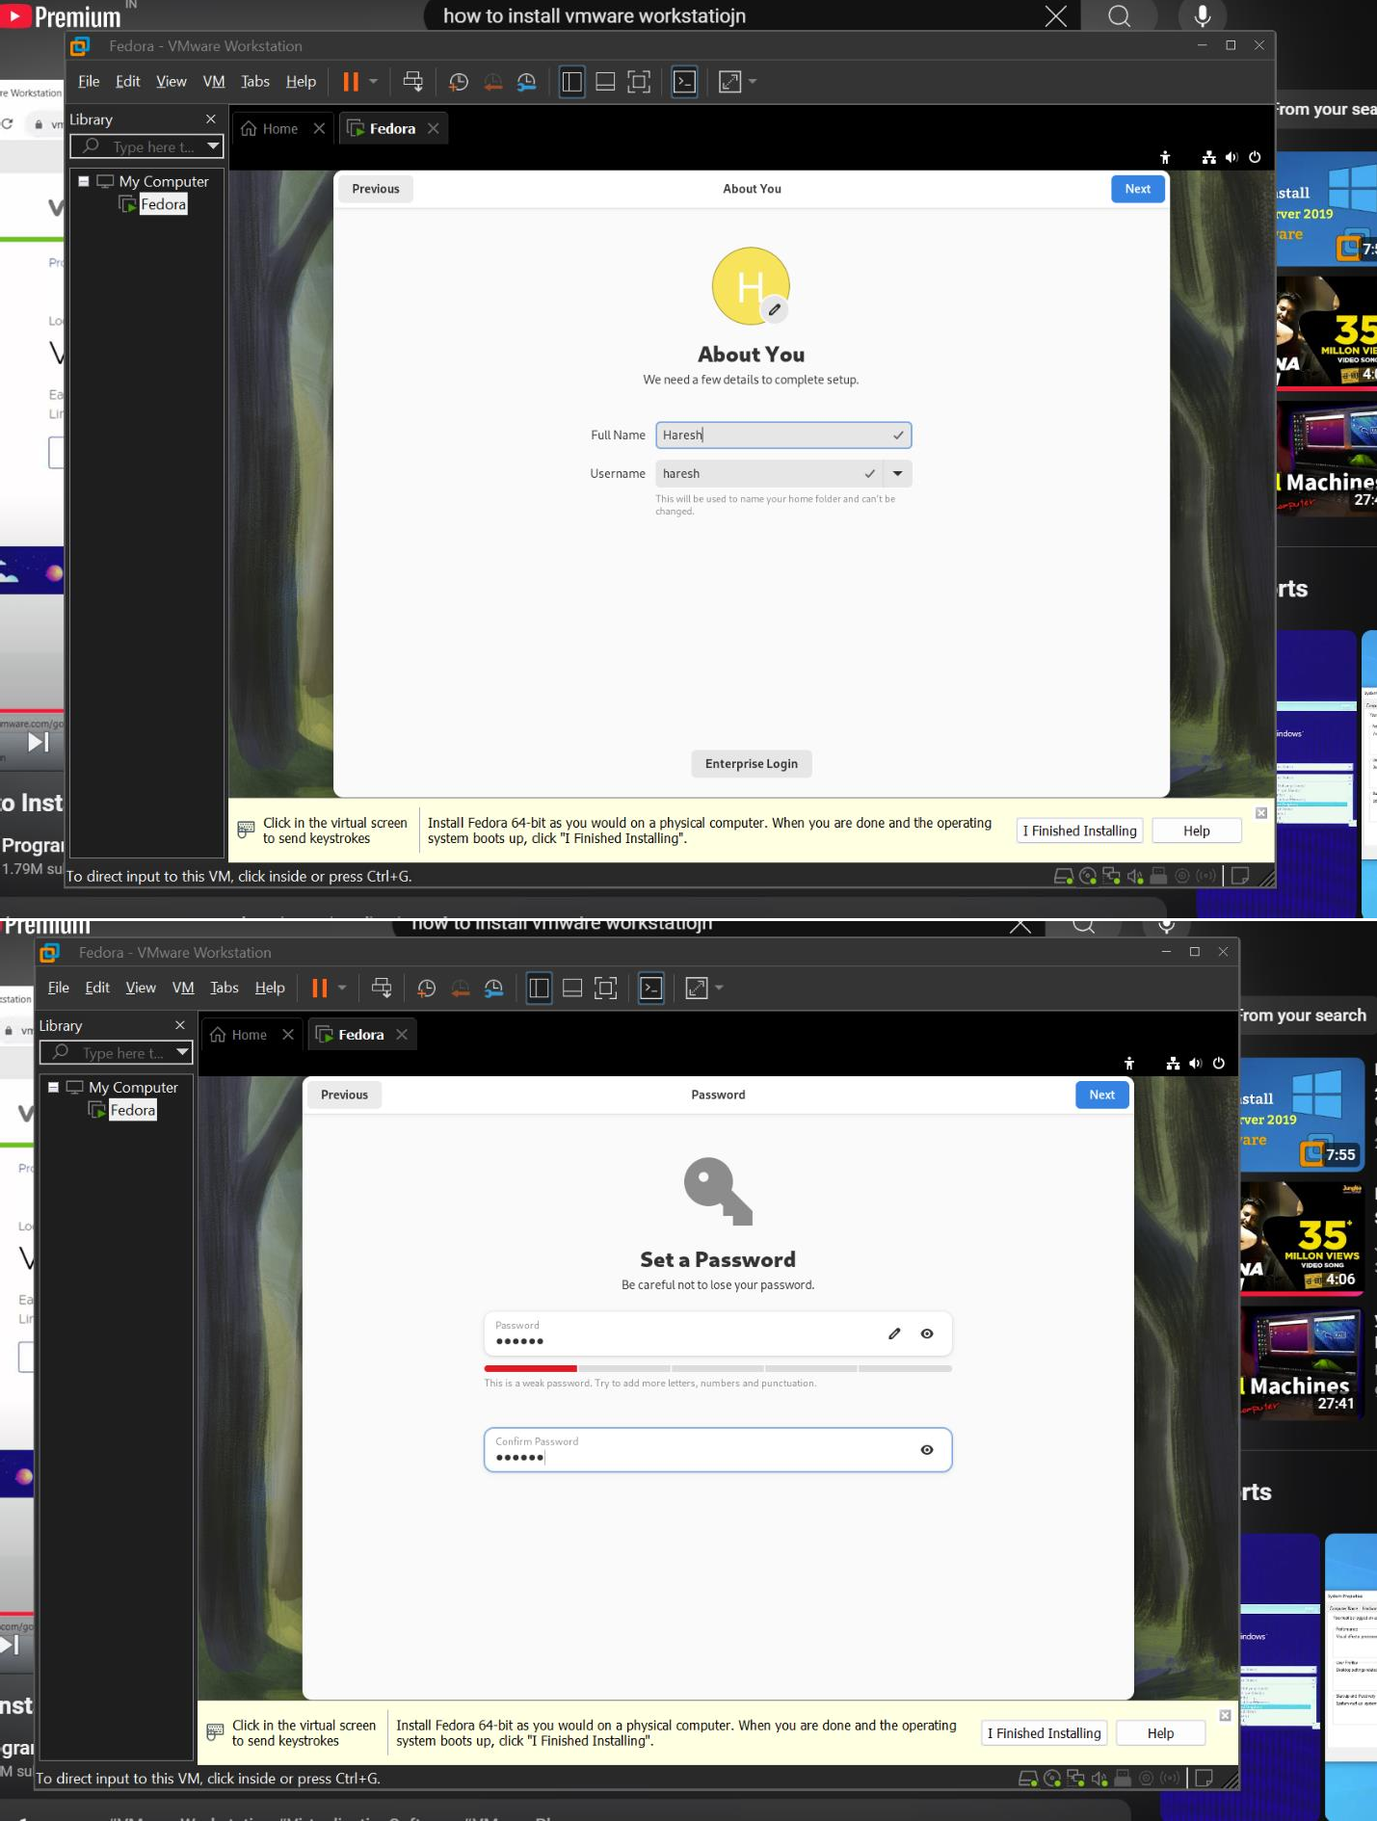

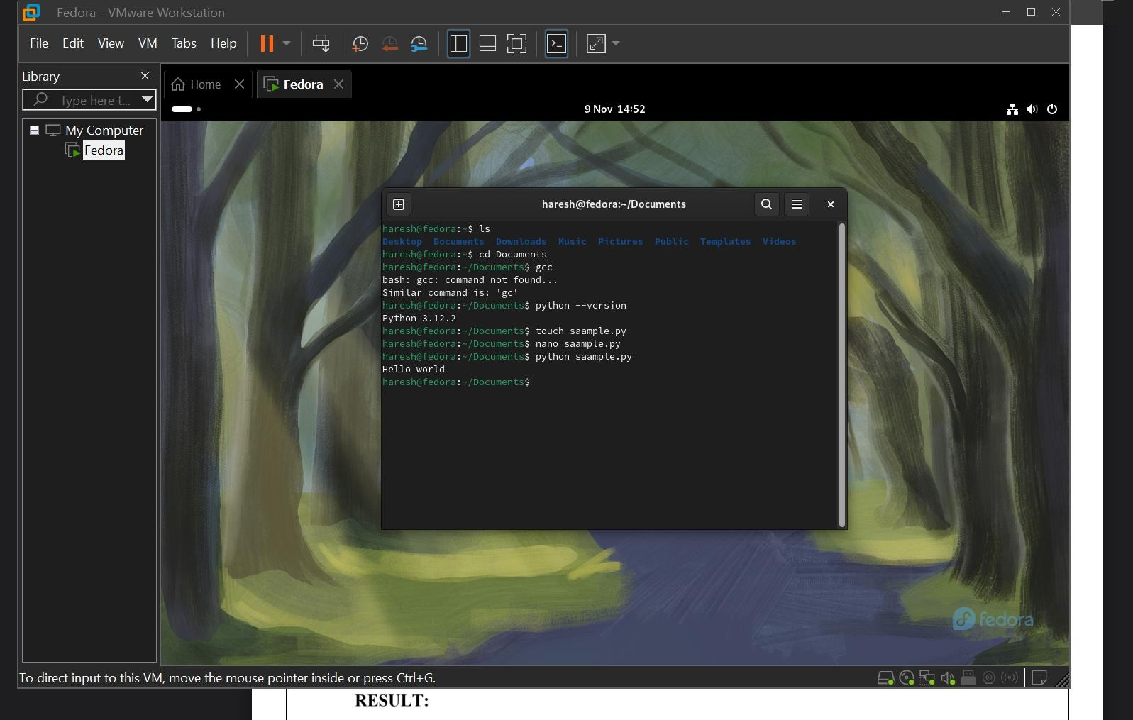

**RESULT:**

Virtual Machine has been successfully set up using VMWare workstation pro and Python program executed successfully.